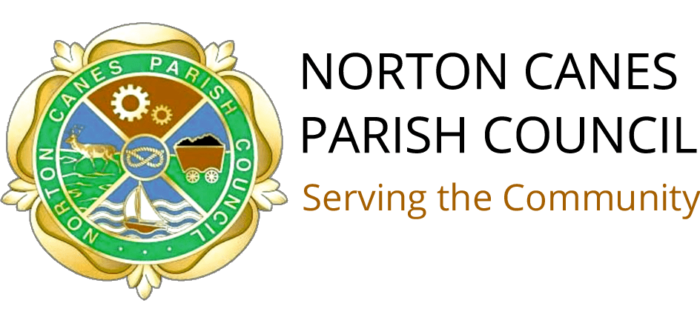
NORTON CANES PARISH COUNCIL Section 137 COMMUNITY GRANT APPLICATION FORM

Norton Canes Parish Council Grants are specifically for community groups based in Norton Canes which are attended by residents of Norton Canes. There is a maximum of £400 available per application, however, the council would be willing to consider a higher amount under exceptional circumstances, this would be at the discretion of the council and would require supporting documents validating the request. The funds are intended to help your group function such as the purchase of materials or room hire, as part of the application process we will consider your answers to determine what proportion of the grant if not all will be allocated, so please list the costing for the full amount you are requesting.

SECTION A

Name of Community Group:
Address where your group Meets:

Contact Name:
Position in Group:
Telephone No:
Email Address:
What does your community group do:

How Many members do you have:
How Many Members live in Norton Canes:
Please give details of the number of people you work with/provide services for?

SECTION B

Are you a Registered Charity YES/NO
Date your Organisation/Club was formed.
Are you part of or affiliated to a National Organisation YES/NO
Have you applied/or received financial support from other organisations including Local Authority?

SECTION C

Grants are a maximum of £400.

How much would you like to apply for:
Please describe how you will spend your Grant:

If you are successful how will the grant benefit your group:

Please provide additional information on a separate sheet of paper.

Grants will not be accepted without the following information:

Bank Account Details

Name on bank account:
Bank account number:
Sort Code:

A copy of your Bank statement and accounts must be provided with this form.

DECLARATION
I declare that I have read and accepted the guidance notes and conditions of funding and that I have answered the questions truthfully.
I also declare that any grant received will be used solely for the purposes outlined in this application. I understand that Norton Canes Parish Council reserves the right to reclaim the grant in the event of it not being used for the purpose specified.
If your grant is accepted, you will be sent a follow up questionnaire in October which must be completed for you to be considered for any future grants.

Signed:
Date:

Please return the completed form along with bank document to the Parish Clerk Ginetta Adams at Email: clerk@nortoncanesparishcouncil.gov.uk
post to: The Parish Clerk, Parish Office, Burntwood Road, Norton Canes, WS11 9RE.

Forms Must be returned to the Clerk by Friday 2nd February 2024

